JIRA COMPLETE SPRINT1,SPRINT2,SPRINT3,SPRINT4

SPRINT1

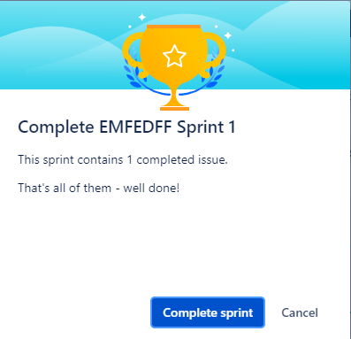

SRPINT2

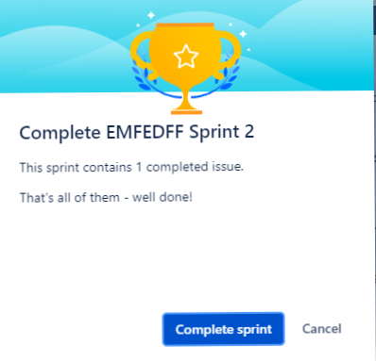

SPRINT3

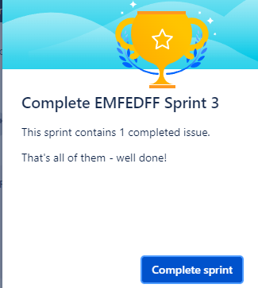

SPRINT4

